Focus on the 52nd St. Corridor
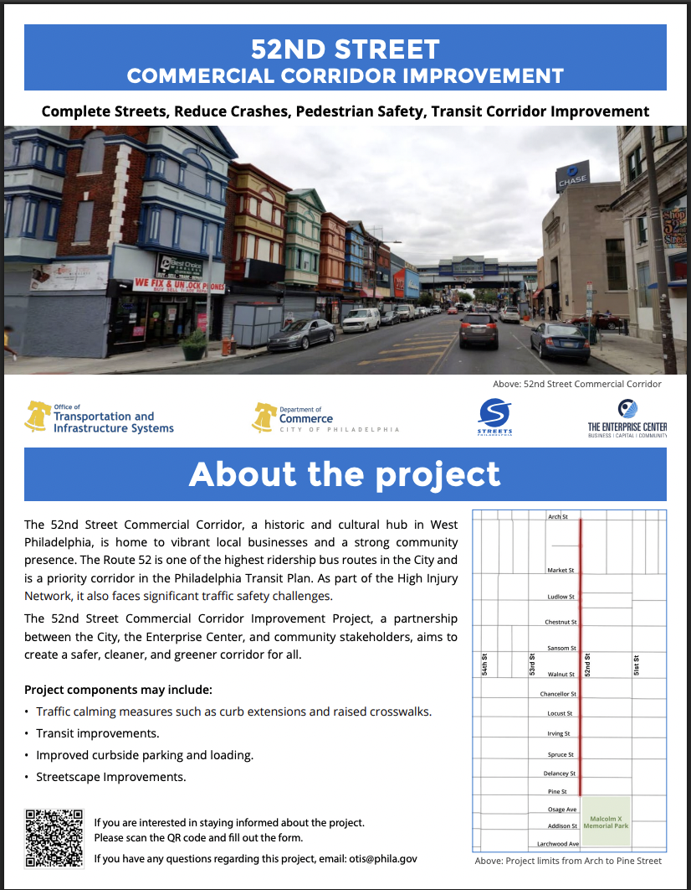
Highlighting the Legacy of Jazz at the Aqua Lounge:
https://libwww.freelibrary.org/calendar/event/125384
https://phillyjazz.us/2017/03/28/aqua-lounge-2/

Articles from the Philadelphia Tribune on the 52nd Street Corridor:
https://www.phillytrib.com/news/business/the-enterprise-center-receives-1-million-to-revitalize-52nd-street-corridor/article_089e3241-e10e-5a18-a3a5-35be83e8ce7b.html
https://www.phillytrib.com/lifestyle/why-gen-z-wants-a-place-on-52nd-street-west-philly-s-black-broadway/article_5415241d-2ff1-5432-bfbd-137141708903.html
https://www.phillytrib.com/news/local_news/senators-bob-casey-and-vincent-hughes-tour-52nd-street-small-businesses/article_bb0e4f36-adb3-5768-ac18-d6df93bc1275.html
https://www.phillytrib.com/news/local_news/return-to-main-street-historic-west-philly-corridor-fights-to-keep-its-identity/article_44b46aa0-ebb7-50a4-9a61-81c9dbfb5d67.html
https://www.phillytrib.com/lifestyle/juneteenth-parade-takes-celebration-on-new-west-philly-route/article_6acd28c6-f143-515d-828d-b60eab74e28d.html

Articles from the Philadelphia Tribune on Hakim’s Bookstore:
https://www.phillytrib.com/news/business/hakims-bookstore-recognized-for-historic-impact-on-community/article_50f9a2da-8fac-598f-8530-883e71e1d9b3.html
https://www.phillytrib.com/news/business/bookstore-owner-graduates-from-power-up-program/article_a0107f3a-031e-5c5f-ba9b-67368924f0fd.html
https://www.phillytrib.com/news/elections/from-church-to-barbershop-to-bookstore-harris-makes-rounds-in-west-philly/article_7ecaa511-807e-56b0-ba01-bf5c424d72ca.html
https://www.phillytrib.com/news/local_news/gov-shapiro-touts-investing-in-tour-of-black-owned-businesses-in-west-philly/article_70080c22-beac-568a-b04a-aae8786a38c0.html
Articles from the Philadelphia Tribune on the Bushfire Theater:
https://www.phillytrib.com/lifestyles/an-evening-with-bill-cosby-to-benefit-bushfire-theater/article_bfc8cda2-07b3-53f9-a240-b338555c299a.html
https://www.phillytrib.com/entertainment/sanchez-to-join-bushfire-walk-of-fame/article_80b91bd3-37a1-520b-81df-26f4105f84d2.html
https://www.phillytrib.com/entertainment/bushfire-theatre-commemorates-historic-obama-appearance/article_5e8d75ac-46a3-588a-b186-89d54372a65d.html

